

Rokela Business Admin
User manual
  - Windows release 0.31.1
A practical guide for counter staff, inventory teams, finance users and administrators.
Use this manual to enter a transaction, confirm its result, find the supporting reports and protect the saved records. Begin with the correct company and role, then follow the workflow for the task.

The essential trading sequence
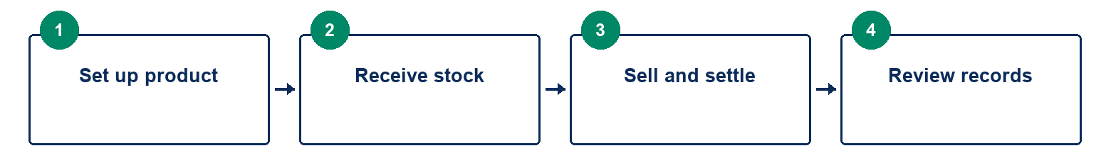

Guide scope
Local Windows workflows, grouped navigation, document entry, stock tracking, finance, service and recovery. External bank, fiscal/tax, email and WhatsApp integrations are deferred. Availability depends on user permissions and company configuration.
Illustrations use training examples. Numbered workflow diagrams explain actions. Screen exhibits show sign in, invoice fields and the calendar; colours and displayed values can vary between releases.

Record a document once and verify the saved result before retrying an uncertain action.

Find the task you need
Read pages 3 to 9 for the daily trading sequence. Use the later sections for specialized work and the final page when a form does not behave as expected.
03 Start with the correct company and user
04 Find screens through business areas or search
05 Create a catalogue product before recording its stock
06 Confirm dates through the calendar before posting
07 Receive goods with an explicit cost and warehouse
08 Select the product and add each invoice line
09 Choose settlement and confirm the document was posted
10 Use holds and recovery without confusing them with sales
11 Open a till when counted cash trading is required
12 Convert quotations and fulfil orders in controlled parts
13 Match supplier invoices and allocate import costs carefully
14 Use stock registers to trace quantities and tracking
15 Count stock and import opening records through review
16 Return goods against the original transaction
17 Use party records and advances to keep balances traceable
18 Post vouchers and allocations through accounting controls
19 Reconcile bank rows and complete cheque lifecycles
20 Move a tender through revisions and approval
21 Track equipment from sale through service
22 Review payroll inputs before running and paying a period
23 Store source documents and print posted records
24 Compare periods and drill into report totals
25 Separate stock age from expiry and slow movement
26 Use approvals and periods before making corrections
27 Verify backups before relying on recovery or sync
28 Resolve common form problems before retrying

Routine working rhythm
Start by checking company, branch, dates and any till session. During trading, add and review lines before posting. At close, reconcile cash/bills and review pending work, backups and synchronization. Follow the supervisor’s controls for approvals and corrections.

  - 01 Getting started

Start with the correct company and user
Rokela Business Admin records trading, stock and accounts in a local company workspace. Confirm the company before entering any document. Available screens and actions depend on your permissions.
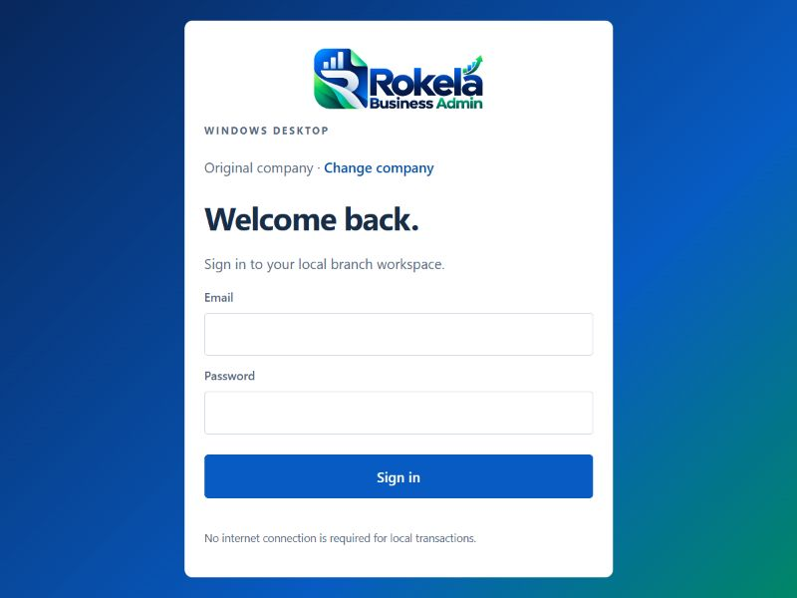
Exhibit 01 Rokela sign in screen
1. Open the installed Rokela Business Admin application. Use Change company if the selected company is not the one you intend to work in. Separate companies have separate records and local accounts.
2. Sign in with your email and password. On a new workspace, the owner completes the first account setup. Do not use a shared owner account for daily counter work.
3. Check the company name, branch and currency in the left panel. Ask the administrator to verify company details, printing information, date controls and tax settings before first trading.
4. Maximize the window on a small laptop. Scroll the main page to reach lower form sections. The menu groups screens by business area; tabs may wrap onto a second row.
5. For training, use a separate test company with synthetic products and parties. Do not post practice invoices, restore backups or rehearse power interruptions against live records.
Confirm the result. The company and branch shown in the workspace match the records you intend to use.
Working note. This manual covers Windows version 0.31.1. Dates may display in your Windows format; use the calendar and confirm the actual day and month. Local transactions work without internet, while configured branch synchronization needs a connection.

  - 02 All workspaces

Find screens through business areas or search
Use the grouped menu to choose an area, then select its screen tab. Go to a screen is the fastest route when you know the task name.

Exhibit 02 Business area to Screen tab to Complete task
1. Choose Overview for the dashboard, reminders and general reports. Choose Sales & purchases for invoices, receipts, orders, tenders, parties, returns and supplier bills.
2. Choose Inventory for the catalogue, product settings, stock, warehouses, counts, barcodes, Excel imports and movement or tracking registers.
3. Choose Finance for accounting, deposits, financial statements, banking, tills, trial balance and periods. After-sales contains equipment, installations and service; People contains payroll.
4. Choose Documents for files and posted document records. Administration contains users, approvals, company settings, diagnostics, sync, backups and audit screens, subject to permission.
5. Press Alt+G and enter a screen name, such as Stock summary. Choose a matching result. If a screen is missing, confirm your role with the administrator rather than trying another account.
Confirm the result. The heading and selected tab identify the screen you intended to open.
Working note. Keyboard shortcuts: F2 New sale; F3 Receive stock; F4 screen search. Keyboard shortcuts in the header lets you change or disable these function keys. Alt+N opens a sale, Alt+R a receipt, Alt+B focuses sale barcode input, and Alt+K sale product search. Alt+H holds a sale when a hold label is supplied. Ctrl+S uses Post document on an invoice or receipt with added lines. Laptop function keys may require Fn.

  - 03 Inventory > Catalogue

Create a catalogue product before recording its stock
A catalogue product defines what can be traded. Creating it does not create stock. Receive goods or import opening stock before selling a stocked item.
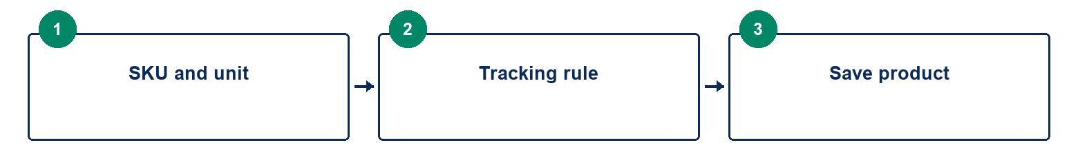
Exhibit 03 SKU and unit to Tracking rule to Save product
1. Enter a unique SKU, product name, category and base unit. Use a clear base unit such as piece or ream. Keep the SKU stable so imports and barcode lookup find the same item.
2. Enter the indicative asking price. This is the starting sale price; an agreed price can be entered on the invoice. Configure any minimum-price or approval rules in the appropriate price settings.
3. Choose the tracking mode. Quantity items use balances; Serial items identify individual units; Batch items retain lot and expiry information.
4. Save the product and confirm it appears in the catalogue. For colours, sizes or other stocked variants, create distinct SKUs and organize them through Variants & bundles.
5. Use Product settings for stock controls and reorder information, and Barcodes for product or pack lookup. Use Equipment setup for equipment relationships and compatibility.
Confirm the result. The saved SKU, unit, tracking mode and asking price are correct; stock remains unchanged until a receipt or opening-stock entry.
Working note. Base units per entered unit controls conversions on a document. For example, 2 cartons containing 12 pieces each produce 24 base pieces when the factor is 12. Confirm whether an entered price is per carton or per piece before posting. Do not create duplicate products simply because an item has another selling pack.

  - 04 Shared form controls

Confirm dates through the calendar before posting
Business date determines the transaction period. Bill due date determines when a credit bill is due. Expiry describes a tracked stock batch; it is not the invoice date.
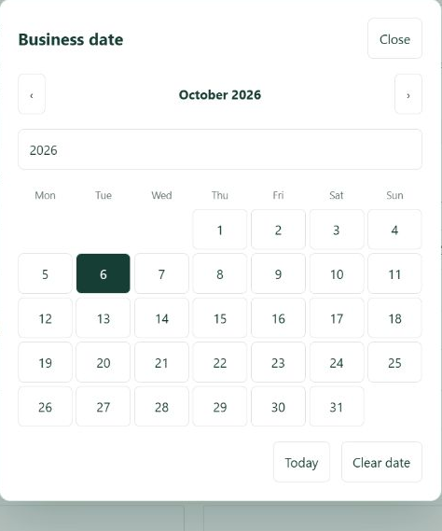
Exhibit 04 Calendar control with month arrows year entry and day choices
1. Click the calendar icon beside the date field. Use the month arrows or year entry to reach the intended period.
2. Choose the day and check the resulting field value. The visible date order follows the Windows/browser display; confirm the day and month rather than guessing from the slashes.
3. Use Today only when the current date is intended. Close dismisses the calendar; clearing is available only for fields that allow an empty date.
4. Before adding or posting the document, check the business date, due date and any expiry together. A closed accounting period or expired stock may block posting.
Confirm the result. The field shows the intended date and its purpose is clear.
Working note. This exhibit isolates the calendar from an earlier application capture. The controls are representative; theme colours and the selected day can differ. Required business dates must not be cleared.

  - 05 Sales & purchases > Receive stock

Receive goods with an explicit cost and warehouse
A goods receipt brings stock into a warehouse. It also records the supplier liability, or goods received awaiting a supplier invoice when that option is selected.
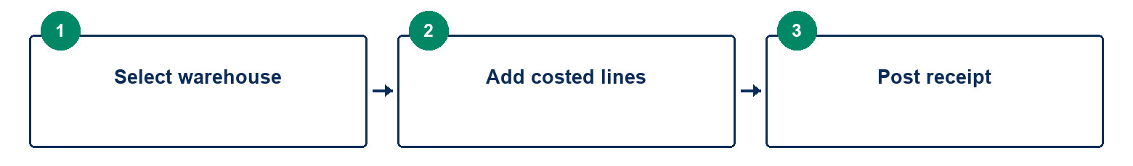
Exhibit 05 Select warehouse to Add costed lines to Post receipt
1. Enter the supplier, business date and bill due date where applicable. Choose the receiving warehouse.
2. Find the product by SKU or name, then select it. Enter quantity, purchase cost per entered unit and the conversion factor. A receipt requires an explicit cost; zero is not a substitute for a supplier cost.
3. For tracked goods, enter the serial or batch and expiry details. A serialized unit must use its individual identity. Split units as required rather than reusing one serial for several units.
4. If the supplier invoice will arrive later, select Supplier invoice to follow. Otherwise the receipt records the supplier bill directly. Click + Add line and review the document lines and subtotal.
5. Post document once. Confirm the success message, document number and warehouse balance. Match a later supplier invoice through Supplier invoices when the receipt was marked invoice to follow.
Confirm the result. Stock increased in the selected warehouse and the document register contains one receipt.
Working note. Example without additional costs: receiving 10 pieces at NLe 60 creates 10 pieces with NLe 600 value. Receiving a catalogue product is different from merely selecting it. If the result is uncertain, check the document register before retrying.

  - 06 Sales & purchases > New sale

Select the product and add each invoice line
Filling the product entry fields prepares a line. The line becomes part of the invoice only after + Add line is clicked. Post document remains disabled when the document has no added lines.
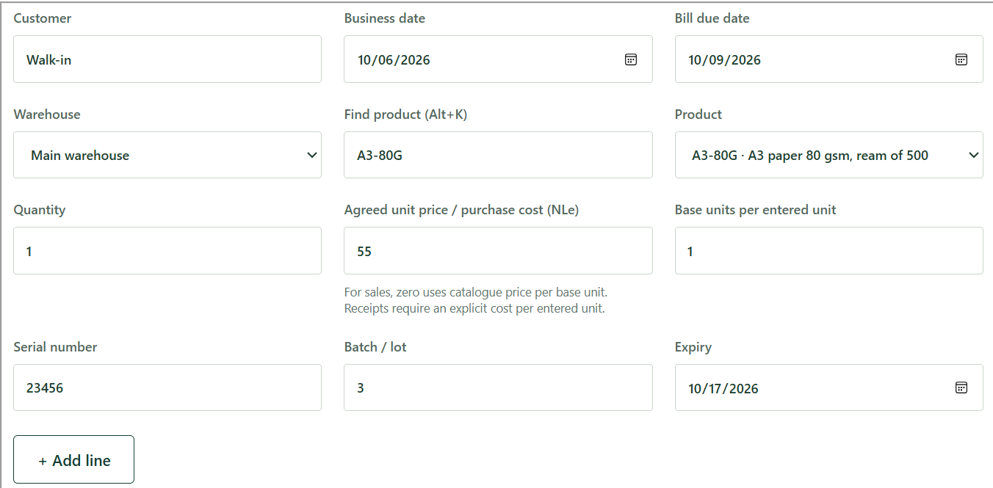
Exhibit 06 Sales invoice fields and Add line from an application screen example
1. Enter the customer, business date, due date for a credit sale and issuing warehouse. For regular customers, use their established party record.
2. Use Find product or open Product. The picker shows catalogue choices and lets you search. Choose a product; typing its SKU alone is not the same as adding an invoice line.
3. Enter quantity and agreed price. For a sale, zero price uses the catalogue price per base unit. When using packs, confirm the conversion factor and the resulting price/quantity.
4. Enter tracking information when the product requires it. Batch selection should respect warehouse availability and expiry. Serial selection must identify an available unit.
5. Click + Add line. Scroll to Document lines and confirm the product, quantity, unit price and amount. Repeat for other products and remove an incorrect draft line before posting.
Confirm the result. The line table contains the intended items and the subtotal is no longer zero for a priced sale.
Working note. Catalogue availability is not stock availability. If there are products but no stock lots, first record a goods receipt or opening stock. Required tracking, warehouse stock and approvals are checked again when the invoice is posted.

  - 07 Sales & purchases > New sale

Choose settlement and confirm the document was posted
A successful post saves the document, stock movement, journal and audit together. A visible success result and the document register confirm completion.
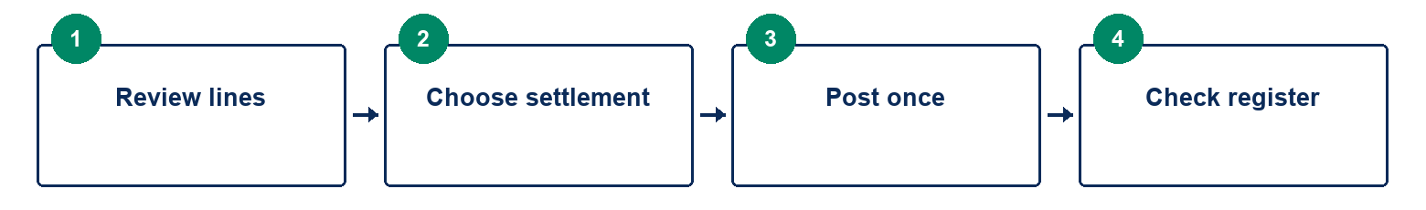
Exhibit 07 Review lines to Choose settlement to Post once to Check register
1. Review every added line, customer, warehouse and date. Choose settlement terms: cash, cheque, bank transfer or credit sale as appropriate.
2. Complete the reference, bank or cheque details requested for the chosen method. For a credit invoice, verify the due date and any customer credit hold or limit.
3. Click Post document once, or use Ctrl+S when the invoice has added lines. Wait while it is processing. Approval rules or a closed period may block the action and explain what is required.
4. After success, note the document number. Open the posted document from the register and print or save the output. Confirm the customer and totals before handing it over.
5. If the result is an error or appears uncertain, read the message and check the register before trying again. Do not assume a second click is needed, and do not edit the database to repair the outcome.
Confirm the result. One invoice is in the register; stock and settlement reflect that invoice; printed output uses posted amounts.
Working note. Training example with no tax: 2 pieces sold at NLe 100 give NLe 200 sales. If their cost is NLe 60 each, cost is NLe 120 and gross profit is NLe 80. Configured tax is calculated at posting; actual invoice totals may therefore differ from this illustration.

  - 08 Sales & purchases > New sale

Use holds and recovery without confusing them with sales
Held sales and recovery copies are unfinished work, not posted invoices. Neither should be treated as revenue or proof of payment.
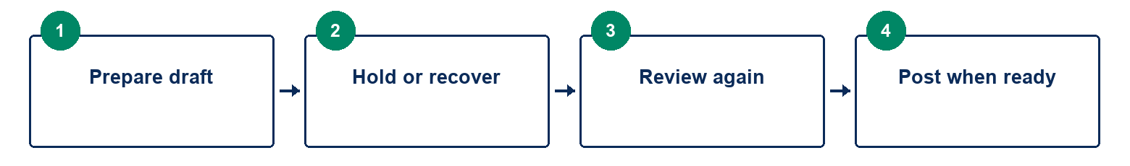
Exhibit 08 Prepare draft to Hold or recover to Review again to Post when ready
1. To pause a prepared sale, enter a useful Hold label and choose Hold sale. Open Held sales to find and recall the saved work.
2. After recalling a hold, check the customer, prices, stock and tracking again. Posting still applies current validation and approval rules.
3. On Windows, automatic sale recovery may offer an unfinished draft after a restart. Review it before restoring. Restore does not itself post the sale.
4. Quotation/order creation and tender header or edited-bid recovery are also supported. An older bid recovery must not overwrite a newer saved revision.
5. If recovery reports it could not save, keep the app open and explicitly hold the sale if possible. Record the issue and preserve the working form until it is safely saved.
Confirm the result. The work is identifiable as a hold or draft until a successful post produces a document number.
Working note. Changing screens may ask whether to leave unsaved work. Read the prompt rather than accepting it routinely. Recovery does not cover every form or partial order-fulfilment input. Never rely on it as a replacement for a posted record or a verified backup.

  - 09 Finance > Tills

Open a till when counted cash trading is required
Till sessions connect recorded cash movements to a cashier and a counted opening/closing amount. Cash drawer hardware behaviour is separate from the recorded session.
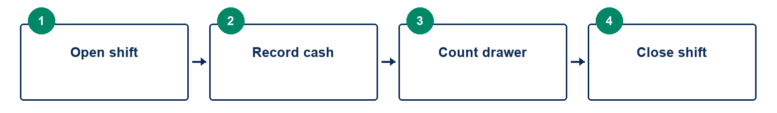
Exhibit 09 Open shift to Record cash to Count drawer to Close shift
1. Select the assigned till or drawer and open the shift with the actual opening cash amount. Confirm the cashier and cash ledger.
2. During the shift, post cash sales and other authorized cash movements through the normal workflows. Avoid recording a movement twice in another voucher.
3. Use the shift details to review included transactions and expected closing cash.
4. Count actual cash at close. Enter the counted amount and review any variance before completing the close.
5. Retain the close report and investigate differences using document and audit records. A supervisor should handle disputed postings or adjustments.
Confirm the result. The closed shift shows the expected amount, counted amount and any variance with its explanation.
Working note. Credit creates a customer receivable; it is not cash received. A cheque is not cleared bank funds until its lifecycle is completed. Recording cash does not guarantee a physical drawer opens: printer and drawer integration must be tested on your counter hardware.

  - 10 Sales & purchases > Orders & quotations

Convert quotations and fulfil orders in controlled parts
A quotation records proposed terms. An order records agreed quantities. Fulfilment posts only the quantities entered for the current action.

Exhibit 10 Quotation to Sales order to Delivery or invoice to Remaining quantity
1. Choose the document type, party, dates and reference. Add the agreed product lines and prices, then save the quotation or order.
2. Open the saved document to review and print it. Sales quotations can be printed as a proforma; a proforma is not a posted tax invoice or proof of payment.
3. Convert an accepted quotation to a sales order. Use Sales controls when goods need reserving or delivery before invoicing.
4. For partial fulfilment, enter quantities to post now; zero skips a line. Choose date, warehouse and required tracking. Do not exceed the remaining quantity.
5. For purchases, receive the selected quantities and choose invoice to follow where needed. For sales, invoice now or deliver first and invoice the delivery later through Sales controls.
Confirm the result. Ordered, fulfilled and remaining quantities are consistent, and previously delivered goods are not issued again on invoicing.
Working note. Keep the customer purchase-order reference on institutional work. Returns do not automatically reopen order fulfilment. Reversals and corrections must respect downstream deliveries, invoices and settlements.

  - 11 Sales & purchases > Supplier invoices and Imports & landed cost

Match supplier invoices and allocate import costs carefully
Supplier invoice matching separates receiving the goods from recognizing the supplier invoice. Landed-cost allocation adds eligible extra costs to the relevant inventory.
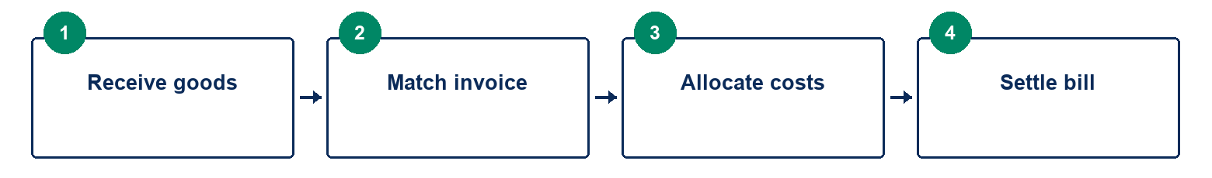
Exhibit 11 Receive goods to Match invoice to Allocate costs to Settle bill
1. Start from the correct supplier and receipt/order. Confirm which goods were received with invoice to follow and how much remains to be matched.
2. Enter invoice reference, invoice date, due date, quantities and supplier prices. Review any price differences before saving.
3. For foreign supplier invoices, confirm the currency and available exchange rate. Review the calculated local amounts and any price/exchange differences.
4. Under Imports & landed cost, select the relevant receipts and cost amounts. Review the allocation and inventory valuation effects before posting.
5. Pay the outstanding supplier bill through the finance workflow and allocate the payment to the intended bill. Reconcile the remaining balance with the supplier statement.
Confirm the result. The supplier bill, goods-received balance, landed-cost allocation and settlement agree without duplicate stock receipt.
Working note. Foreign purchasing is supported; a complete foreign-currency sales/banking and revaluation workflow is not covered by this release. Reversing a receipt may be blocked while landed cost, matching invoices or later stock use depend on it.

  - 12 Inventory > Stock summary and registers

Use stock registers to trace quantities and tracking
Stock summary shows the available quantities and value by warehouse and tracking identity. Movement and tracking registers explain how the balance arose.
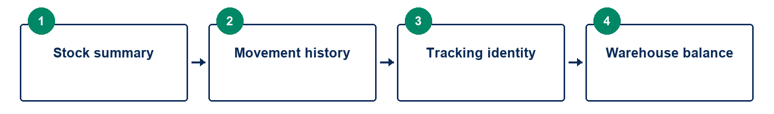
Exhibit 12 Stock summary to Movement history to Tracking identity to Warehouse balance
1. Choose the product and warehouse filters needed for the question. Separate company, branch and warehouse concepts; a warehouse is a location within the current workspace.
2. Open Movement register to review receipts, sales, transfers, counts and returns for the selected item.
3. Open Tracking register or Equipment lookup for serial/batch identity and associated history. Confirm the lot or serial before issuing goods.
4. Use Warehouse controls for authorized transfers. Enter source and destination, quantities and exact tracking identity; confirm the resulting balances.
5. Review reorder suggestions and Product settings. Investigate missing or negative-looking stock using the movement history instead of changing catalogue quantities directly.
Confirm the result. Opening balance plus movements explains closing quantity; transfers retain the item identity and do not create a second receipt purchase.
Working note. Aging stock and expired stock are different questions. Expiry is a tracking date; stock age follows receipt history. Quantity controlled items, serialized units and batches require different counting and issuing details.

  - 13 Inventory > Count sessions and Import from Excel

Count stock and import opening records through review
Count sessions and imports provide controlled ways to correct or initialize stock. A preview is not a committed import.
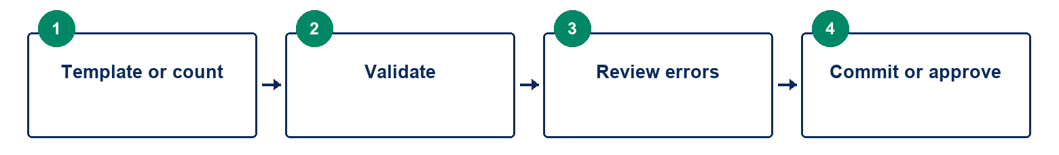
Exhibit 13 Template or count to Validate to Review errors to Commit or approve
1. For a physical count, create a count session for the warehouse and record the actual quantities or tracked identities observed.
2. Review differences and submit/approve according to permissions. Count adjustments may require another person, and stale counts can be rejected if stock changed after counting.
3. For Excel import, select the supported import type and download its template. Use templates for products, opening stock, serial/batch stock, prices or counts as offered.
4. Fill the workbook with consistent SKUs, units, warehouses, dates and tracking. Upload and validate it. Read warnings and correct every blocking row error.
5. Commit only the reviewed workbook. Save the result/reference and inspect the catalogue or warehouse balance. Retrying the same committed import should not create duplicate records.
Confirm the result. The accepted import or approved adjustment has one audit trail and the expected stock result.
Working note. Use an error workbook where offered to locate row problems. Duplicate serials, malformed workbooks, unsupported tracking and changed data can prevent commitment. General whole-company, party or ledger migration is not the same as the supported stock/product import templates.

  - 14 Sales & purchases > Returns

Return goods against the original transaction
Returns preserve the relationship to the original sale or purchase. A return and a whole-document reversal serve different purposes.
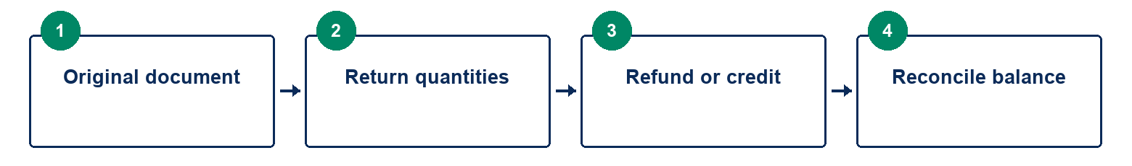
Exhibit 14 Original document to Return quantities to Refund or credit to Reconcile balance
1. Find the original document and inspect its product lines. Choose the items and quantities being returned.
2. Confirm the return date, warehouse and the original serial/batch identity. Do not return more than the eligible original quantity.
3. Review the original price, tax and cost treatment. Enter the reason and any required approval before posting.
4. For a paid sale, use the permitted refund or held customer credit workflow. For a purchase, use the corresponding supplier credit/refund allocation.
5. Check the return document, stock movement and remaining credit/bill balance. If replacement goods are sold, record their separate sale and any appropriate credit use.
Confirm the result. The return is linked to the original document, and both stock and the refund/credit are traceable.
Working note. Do not use a full reversal to represent a partial return. A serialized equipment return can affect warranty validity; resale may start a new warranty lifecycle. Downstream dependencies and closed periods can block corrections.

  - 15 Sales & purchases > Customers & suppliers and Finance > Deposits & advances

Use party records and advances to keep balances traceable
Party masters make contact details, payment terms and credit controls consistent. Advances record money received or paid before the final invoice exists.
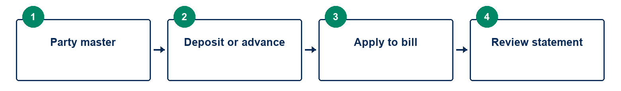
Exhibit 15 Party master to Deposit or advance to Apply to bill to Review statement
1. Create or open the customer/supplier record. Enter the name, contact details, payment terms and institutional contacts needed for the relationship.
2. Apply credit limits or holds through authorized settings. Review customer statements and ageing rather than relying only on the latest invoice.
3. For a deposit or advance, choose the party, direction, amount, date and cash/bank account. Record a clear reference and post once.
4. When an invoice is available, apply the advance to that party’s eligible bill. Partial application leaves the remainder available; review both balances.
5. Use refund or reversal actions only when the business reason and dependencies allow them. Check the resulting statement after each allocation.
Confirm the result. The party statement shows invoices, payments, advances and remaining balances without counting a deposit as a second invoice payment.
Working note. A legacy free-text customer name may not receive all master-record credit controls. Keep names consistent and prefer the established party record. Do not treat an unallocated deposit as sales revenue merely because cash was received.

  - 16 Finance > Accounting

Post vouchers and allocations through accounting controls
Accounting provides statements, cash flow, day book, bills, bank reconciliation, budgets and voucher entry. Operational sales and receipts already create their journals.
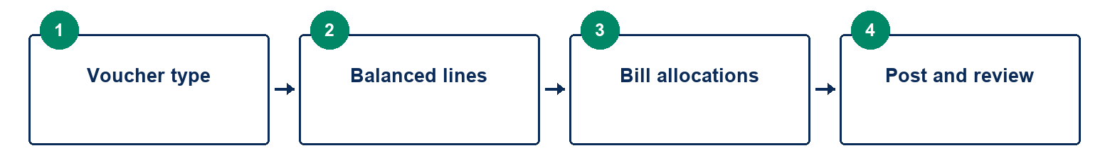
Exhibit 16 Voucher type to Balanced lines to Bill allocations to Post and review
1. Choose the report view and date range, then Refresh reports. Use Bills & ageing to find unsettled customer and supplier balances.
2. For an authorized journal, receipt, payment or contra, choose the voucher type, date, reference and permitted ledger accounts.
3. Enter debit and credit lines so the voucher balances. Add bill allocations when receiving or paying against existing invoices; select the correct party and bill.
4. Review the voucher and allocations before posting. Use the document/register view to verify the saved entry and its remaining bill balances.
5. Review the trial balance, day book and ledgers to investigate differences. Use period and approval controls for corrections; do not edit a posted journal in place.
Confirm the result. Total debits equal total credits, the intended bills were allocated, and the ledger shows one posting.
Working note. A receipt can be allocated to several bills when the workflow permits. Partial payments leave a balance; allocations must not exceed the eligible outstanding amount. Do not post a manual journal that duplicates the automatic journal from a trading document.

  - 17 Finance > Banking and Banking tools

Reconcile bank rows and complete cheque lifecycles
Statement import helps compare recorded entries with bank evidence. A proposed match requires review; importing a statement does not automatically post every bank row as a new voucher.
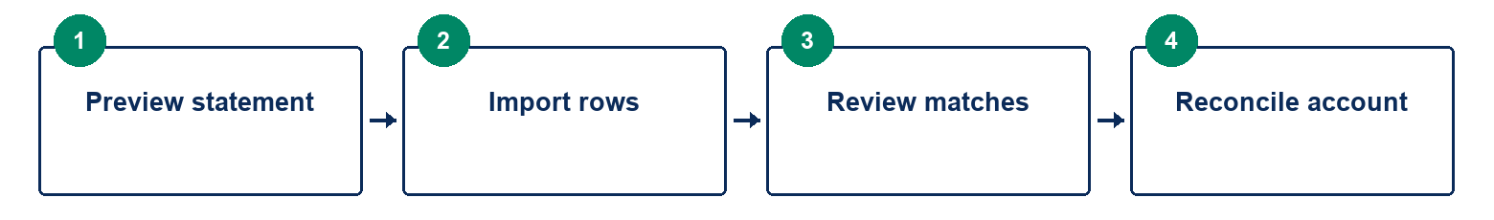
Exhibit 17 Preview statement to Import rows to Review matches to Reconcile account
1. Choose the bank account and statement reference. Enter opening/closing balances and upload or paste the supported CSV format.
2. Preview the current CSV and inspect dates, references and amounts. Correct format errors before importing.
3. Review proposed matches to recorded journal entries. Confirm only genuine matches and inspect unmatched items. Avoid pairing a row merely because its amount is similar.
4. For received cheques, record reference, bank, amount and relevant dates; progress through deposit, clearance or bounce as appropriate.
5. Use Banking tools for issued-cheque and related controls offered there. Review remaining unmatched entries and reconciliation history before signing off the account.
Confirm the result. Statement rows, ledger entries and cheque status agree, and reviewed matches have a traceable history.
Working note. Connected-bank downloads/payments and bank-specific cheque layout printing are not provided by the deferred external integrations. Reconciliation concerns recorded bank evidence; it is not authorization to send a bank payment.

  - 18 Sales & purchases > Tenders

Move a tender through revisions and approval
Tender records retain the opportunity, bid revision, costing and outcome. Work on a saved revision rather than overwriting an earlier bid informally.

Exhibit 18 Opportunity to Costed revision to Approval to Submission to Outcome
1. Register the tender reference, institution, title, officer, dates, submission method and notes. Attach source documents through the document workflow.
2. Open the tender and enter product quantities, proposed prices and costs. Review estimated value and margin before saving the bid.
3. Save revisions with a clear reason. The expected revision protects against overwriting a bid another user has changed.
4. Submit for the required approval and then record submission/outcome through the available status actions.
5. For an award, review the awarded quantities and conversion to an order. For a loss or closure, record the outcome so it remains visible in the tender history.
Confirm the result. The current bid revision, approval and outcome are recorded; award conversion links to the resulting order.
Working note. Draft recovery can restore edited tender work on Windows, but a stale bid must be reviewed rather than forced over a newer version. Deadline and attachment access depend on the saved tender and your permissions.

  - 19 After-sales > Equipment lookup Installations and Service jobs

Track equipment from sale through service
Equipment records connect a serialized unit to its sale, installation, warranty and service history. Service parts consumption is a stock movement, not just a note.
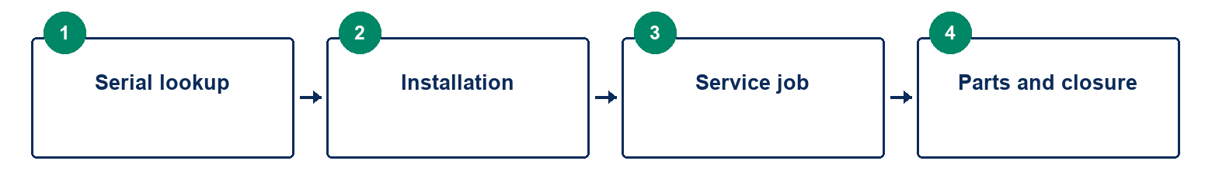
Exhibit 19 Serial lookup to Installation to Service job to Parts and closure
1. Use Equipment lookup to search the serial and confirm the unit, customer and warranty history. Use Equipment setup for supported relationships and compatible accessories.
2. Create or open the installation record. Assign and schedule the work, record completion details and review the installation certificate before printing.
3. For service, register the job, equipment/customer, symptoms and warranty status. Update diagnosis and assigned work as the job progresses.
4. Issue parts through the service workflow with the correct warehouse and tracking. Return unused parts through the corresponding action.
5. Review service charges or warranty cost treatment, then close the job. Use maintenance plans and reminders for recurring visits where configured.
Confirm the result. The serial lifecycle and service history remain linked, consumed parts reduce stock once, and completion documents reflect saved work.
Working note. Field work can be entered locally on Windows; an Android field client is outside the current scope. A saved warranty or tax setting is not a substitute for the business policy and current applicable rules.

  - 20 People > Payroll

Review payroll inputs before running and paying a period
Payroll calculations use saved employees, period inputs and dated settings. Review the settings and statutory assumptions before relying on the resulting run.
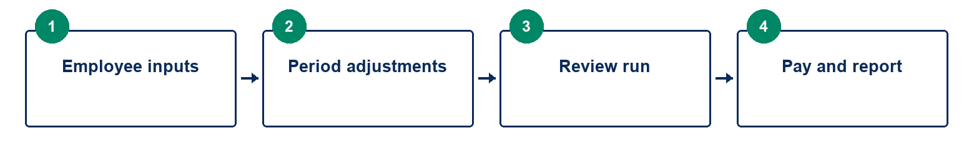
Exhibit 20 Employee inputs to Period adjustments to Review run to Pay and report
1. Create or review employee records and recurring salary/allowance data. Keep start/end dates and payment details current.
2. Select the payroll month and enter the supported adjustments such as unpaid days, overtime amounts, bonuses or deductions.
3. Review PAYE/NASSIT and related dated settings with the responsible payroll specialist. Record employee loans and permitted repayment details where relevant.
4. Run the period once and inspect each employee result, total deductions, employer costs and journal totals. Use duplicate-run controls rather than submitting the same month repeatedly.
5. Print payslips and record employee payments/allocations. Use offered statutory schedules, remittance or bank-file outputs after checking their destination requirements.
Confirm the result. The payroll register, payslips, employee payments and outstanding amounts reconcile for the selected month.
Working note. A full attendance register, accrued leave administration and arbitrary pay-head formula engine remain expansion work. Entered payroll adjustments are not proof that those additional modules exist. Current statutory rates and filing requirements must be verified by the business.

  - 21 Documents > Document library and Documents

Store source documents and print posted records
The library stores evidence linked to business work. Printed invoices and receipts should come from posted records, not from screenshots of an unfinished form.
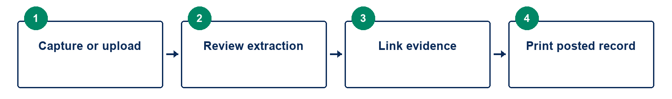
Exhibit 21 Capture or upload to Review extraction to Link evidence to Print posted record
1. In Document library, upload or capture the source file and choose the appropriate document type and business link.
2. Review extracted text or suggested fields before accepting them. OCR can misread dates, decimal points, quantities and supplier references.
3. Search by the saved document information and open the original or preview to inspect it. Use permitted revisions rather than silently replacing evidence.
4. Open a posted invoice, receipt, order, statement or payslip and choose Print / save PDF where offered. Check company details, paper layout and totals.
5. Choose a printer or PDF destination in the system dialog. If printing fails, keep the posted document number and reprint from the register; do not repost the transaction.
Confirm the result. The source document is accessible to authorized users and the print output matches the posted record.
Working note. Offline OCR is available in the Windows package. A scanner, printer or fiscal device still needs hardware verification. Email/WhatsApp sharing and live fiscal connectivity remain deferred; the manual does not instruct you to activate unavailable providers.

  - 22 Overview > Reports and Finance > Financial statements

Compare periods and drill into report totals
Reports answer different questions depending on date range, as-at date and grouping. Use the report’s filters before comparing totals.
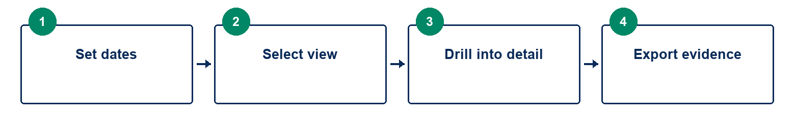
Exhibit 22 Set dates to Select view to Drill into detail to Export evidence
1. In Reports, choose dates and the report view. Group sales by the appropriate period, customer or product and drill into document details when a total needs explaining.
2. Use day book/ledgers, stock, bills/ageing and audit views according to your permissions. Export or print the current filtered result when offered.
3. In Financial statements, open Comparative statements. Choose profit and loss, balance sheet, cash flow or funds flow, then select the current and comparison periods.
4. Review current, previous and change columns. A percentage change is not shown when the prior amount is zero. Balance sheets compare as-at balances, while flow statements use their periods.
5. Use ratios as indicators and review their underlying ledger amounts. Save report settings for dates/view/grouping where offered, and reset saved settings when they no longer suit the task.
Confirm the result. The chosen dates and grouping explain the total, and each comparison uses the intended periods.
Working note. Use like-for-like periods when possible. Report settings are per user/device and do not change transactions. Current ratio coverage does not establish every advanced accounting analysis or alternative inventory valuation method.

  - 23 Overview > Reports > Stock ageing

Separate stock age from expiry and slow movement
Stock ageing shows how long remaining stock has been held. Slow-moving status reflects dispatch history and the selected threshold; neither is the same as the expiry date.
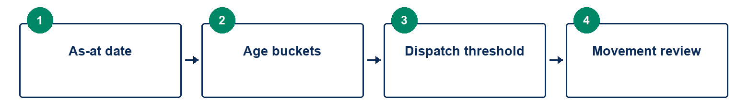
Exhibit 23 As-at date to Age buckets to Dispatch threshold to Movement review
1. Choose the report as-at date and slow-moving threshold in days. The report evaluates history up to that date.
2. Review the 30-, 60-, 90-day and older age buckets by warehouse and tracking identity. Compare total quantity and value with the corresponding stock balances.
3. Inspect last dispatch and slow-moving status. No recent dispatch, or old stock never dispatched, can make a row slow-moving.
4. Drill into the product movements to understand receipts, transfers, sales, service use and reversals.
5. Export the reviewed result and discuss replenishment, expiry exposure or clearance with the responsible manager. Do not change stock valuation merely to match a preferred age bucket.
Confirm the result. Age buckets explain remaining quantity, and any unknown age is separately visible for investigation.
Working note. Transfers retain receipt age. Positive returns or count adjustments start a layer on their document date. Unknown receipt history is disclosed rather than assigned an invented date. Age allocation does not change the existing weighted-average accounting valuation.

  - 24 Administration > Approvals Controls & exceptions and Finance > Periods & tax

Use approvals and periods before making corrections
Approvals and period controls protect transactions that need review. Correction should remain visible in the document and audit history.
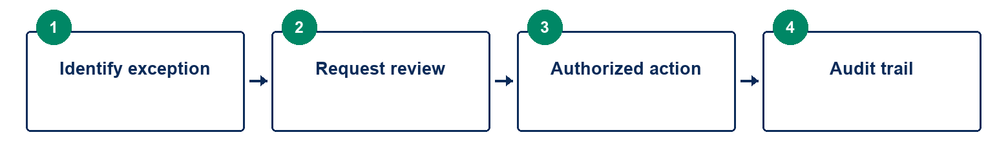
Exhibit 24 Identify exception to Request review to Authorized action to Audit trail
1. Review the reason a transaction was blocked: discount/below-cost pricing, credit limit, backdating, refund, count adjustment or another configured control.
2. Submit the appropriate request and supporting reason. A permitted reviewer should inspect the values and related document before approving.
3. Return to the transaction and use the authorized approval. Check that the final posted amount and quantity still match what was approved.
4. For a correction, use the supported return, reversal or adjustment action. Enter a meaningful reason and check downstream dependencies.
5. Before closing a period, reconcile trading, bank, bills, payroll and stock reports. Treat period closing as a controlled decision, not a routine button used to hide discrepancies.
Confirm the result. The approval, correction and audit trail explain the final records; closed-period rules remain respected.
Working note. Users & permissions lets an administrator assign roles, lock accounts and reset access. Only the responsible administrator should change permissions. Never change raw database history to avoid a control or to repair an integrity warning.

  - 25 Administration > Backups & integrity and Branch sync

Verify backups before relying on recovery or sync
Local saving, backup and branch synchronization are distinct protections. A pending sync count does not mean a local transaction was not saved.
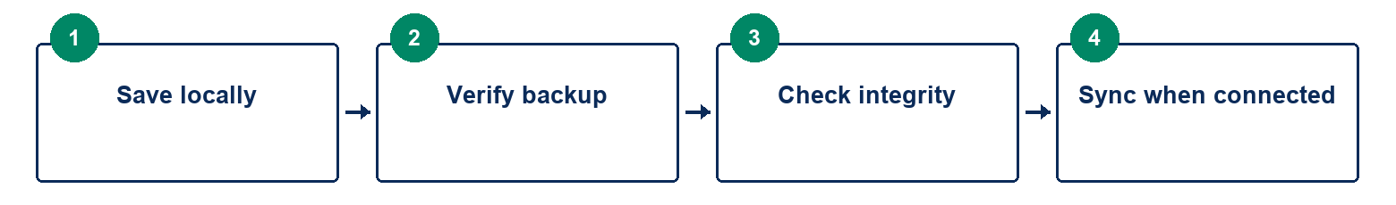
Exhibit 25 Save locally to Verify backup to Check integrity to Sync when connected
1. Use Back up records or Backups & integrity to create a manual backup. Confirm the reported backup and any configured copy-folder result.
2. Configure automatic backup interval, retention and a second copy folder where permitted. Automatic backups run while the desktop application is open.
3. Run Check records now and review whether the sealed history and database guards are valid. Preserve evidence and investigate warnings rather than editing the database.
4. In Branch sync, use administrator-provided HTTPS server/branch credentials and review protocol/schema compatibility and conflicts. Retry after connectivity returns; do not publish secrets in screenshots.
5. Before a restore or upgrade, retain the current data and a verified backup. Restore only a compatible backup for the right company/branch, with the explicit confirmation requested by the app.
Confirm the result. Backup verification/copy status is known, integrity is reviewed, and pending sync is reconciled after reconnection.
Working note. A cloud-synced folder is only a copy destination, not proof of a managed cloud backup service. Do not restore while relying on an unfinished draft. Older releases may reject newer databases; use the approved pre-upgrade backup and rollback procedure.

  - 26 Troubleshooting

Resolve common form problems before retrying
Most entry problems come from an incomplete line, missing stock, tracking requirements, dates or permissions. An uncertain post needs a register check before a retry.
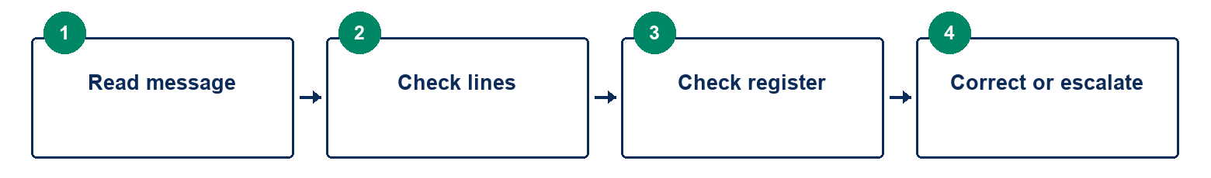
Exhibit 26 Read message to Check lines to Check register to Correct or escalate
1. Product list empty: clear the product search, open the picker, and confirm the SKU exists in Catalogue. A product can exist even when its warehouse stock is zero.
2. Post document disabled: scroll to Document lines. Select the product and click + Add line; filling the upper fields alone does not add it. Check quantity, price/cost and tracking.
3. Post rejected: read the visible message for stock, serial/batch, expiry, credit, approval or closed-period conditions. Correct the stated problem rather than clicking repeatedly.
4. Post seems unresponsive: check the page for a message and the document register for the result. If the workspace stopped responding, preserve the document reference and reopen the app; review saved transactions before retrying.
5. Date or small-screen difficulty: use the calendar icon, verify day/month, maximize the window and scroll the main content. If a shortcut opens Find on page as well as a screen, confirm you installed the 0.31.1 correction.
Confirm the result. You can identify whether the work is unposted, rejected or already saved before taking another action.
Working note. Recovery could not save: keep the app open and hold the sale if possible. Printer failed: reprint the saved document, not the sale. Screen missing: ask about role permissions. Integrity failed: retain a backup and escalate. Record the app version, screen, exact message and document number when requesting help; exclude passwords and sync keys.

